HDB Technical Assessment Submission
Data Engineering • Architecture • Governance

Submitted by:
ILANGO RAMESH

Date:
24 Aug 2026

Role Applied:
Data Engineer

Professional Summary
Experienced Data Engineer with proven expertise in building scalable data pipelines, preparing ML-ready datasets, and processing IoT telemetry at enterprise scale. Skilled in designing resilient architectures, enforcing data quality, and delivering production-grade systems optimized for operational resilience. Adept at implementing public sector data governance frameworks, including compliance with the Personal Data Protection Act (PDPA), while ensuring secure, reliable, and high-throughput data solutions.

Executive Summary
This project delivers an end-to-end ETL pipeline and AWS architecture to support the Housing & Development Board (HDB) in analyzing resale flat prices. The solution ingests datasets from data.gov.sg (2012–2016), applies programmatic data cleaning and transformation, and produces curated, ML-ready datasets. It enforces data quality, governance, and PDPA compliance while enabling secure exploitation through Athena, Tableau, and AI/ML models. The outcome is a resilient, scalable, production-grade system that supports both batch ingestion and analytical exploitation under operational constraints. This architecture enables data-driven policy decisions for housing affordability by providing reliable and curated datasets.

Problem Statement
The Data Science Team requires reliable, cleaned, and transformed datasets to analyze resale flat prices. Raw datasets from data.gov.sg contain inconsistencies, duplicates, and potential anomalies that must be addressed. Without a structured ETL pipeline, manual intervention would be error-prone and non-scalable. Additionally, compliance with PDPA and secure ingestion from public endpoints into private VPCs is mandatory.
The problem is therefore twofold:
- Data Engineering Challenge → Build a programmatic ETL pipeline to clean, validate, and transform resale flat datasets.
- Architectural Challenge → Design a secure, scalable AWS architecture for ingestion and exploitation, ensuring compliance and operational resilience.

Objectives
- Scalability → Support large batch files (>100 MB) and future extensions to streaming ingestion.
- ML Readiness → Deliver curated Silver/Gold datasets suitable for predictive modeling.
- Governance → Enforce PDPA compliance, IAM role segregation, and auditability via CloudWatch/CloudTrail.
- Resilience → Implement monitoring, alerting, and retry logic to ensure reliable operations.
- Security → Use Internet Gateway for ingestion, PrivateLink for exploitation, and encryption for data protection.
- Performance → Optimize query execution via Athena and structured data modeling for BI dashboards.

Coding Section
1. Combine Datasets
Merge multiple source files into a single master dataset. This ensures all attributes across files are preserved and provides a unified foundation for profiling and validation.
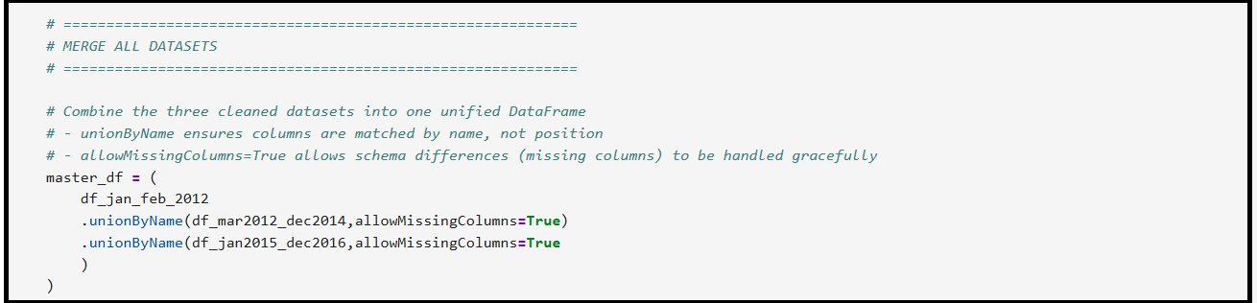
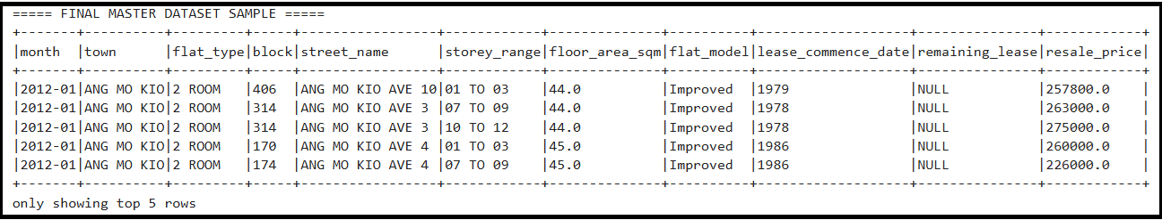

2. Data Profiling
Analyze the dataset to understand distributions, missing values, duplicates, and anomalies. Profiling helps define validation rules and detect data quality issues early.
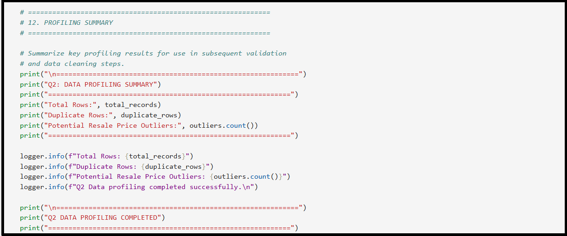
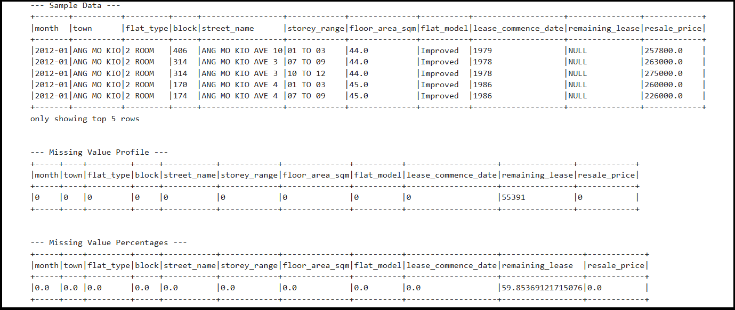

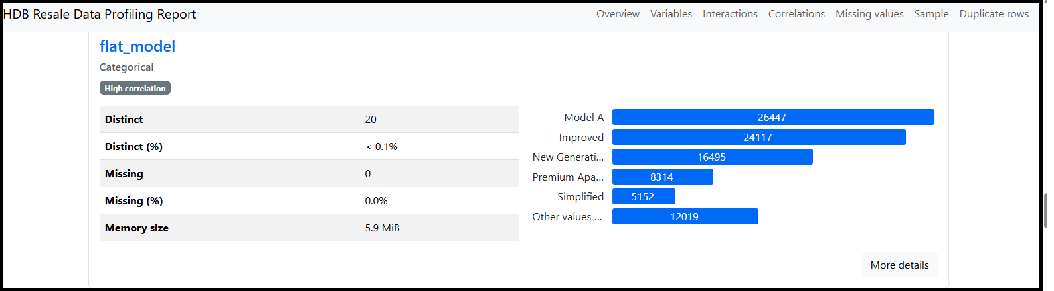

3. Validation Rules
Validation rules are metadata-driven, allowing easy configuration and adaptability to evolving business logic.
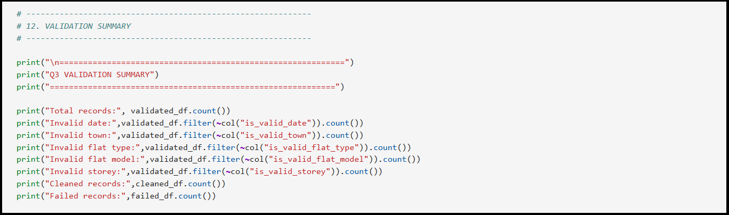
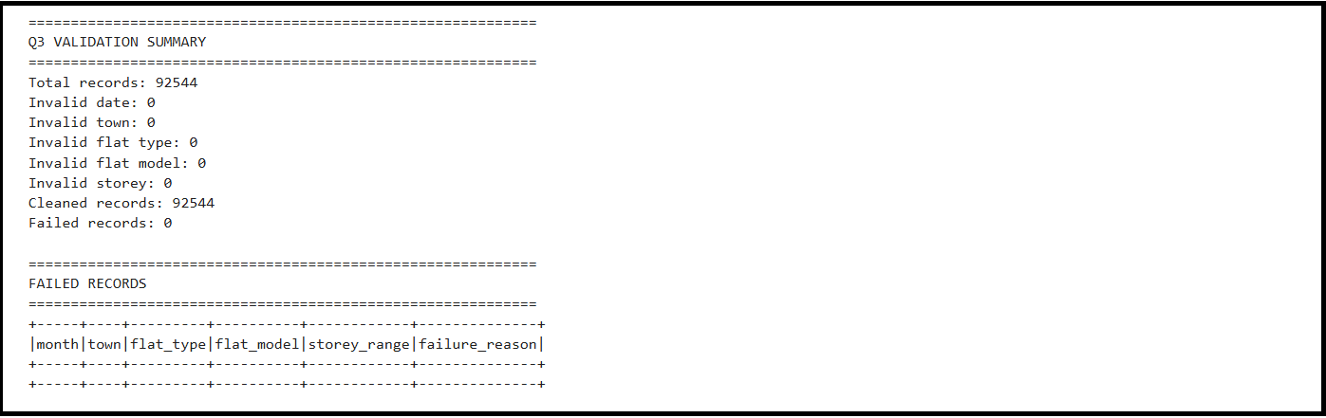
4. Remaining Lease Calculation
Recompute the remaining lease based on a 99-year assumption. Round down to years and months to reflect realistic lease durations for each flat.
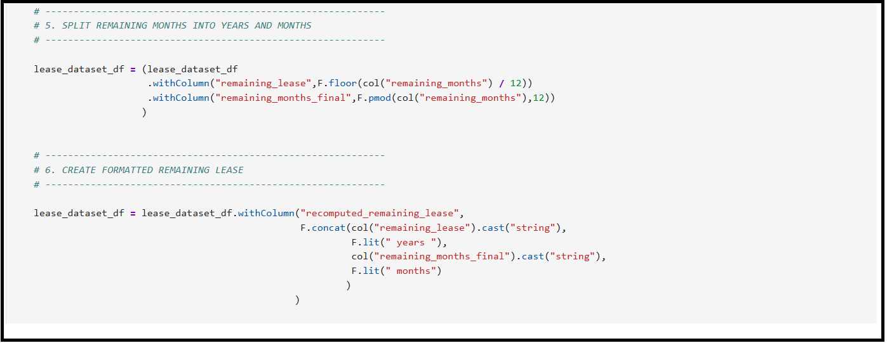

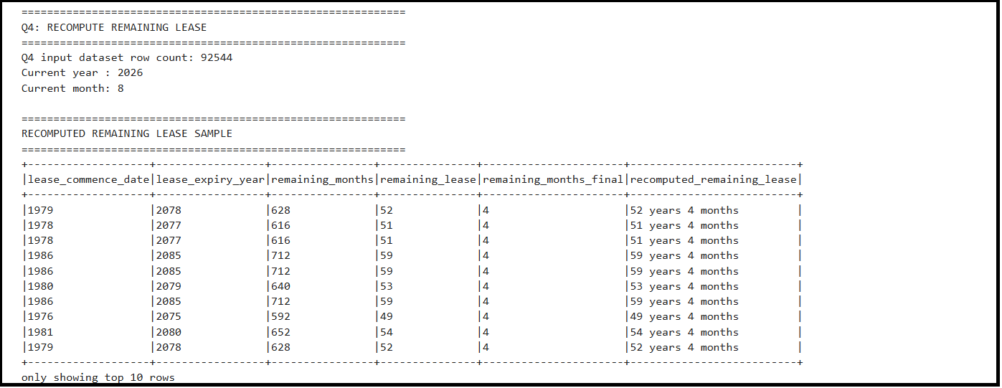

5. Deduplication
Identify duplicate records using a composite key (all columns except resale price). Keep the record with the higher resale price and move the lower one to the failed dataset.
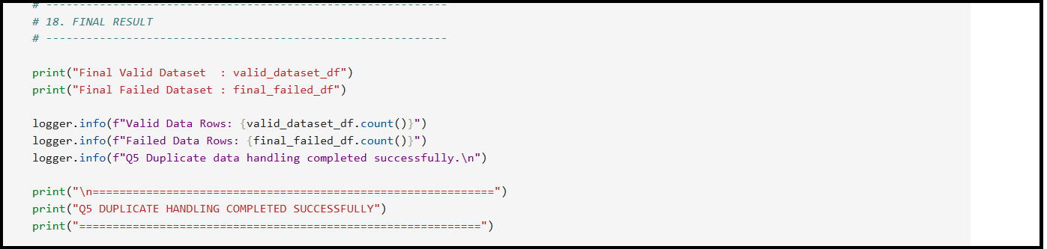
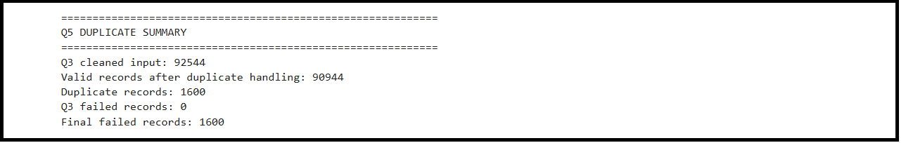
6. Anomaly Detection
Anomalous records are flagged for human review and, where appropriate, routed through automated correction pipelines to ensure governance maturity.
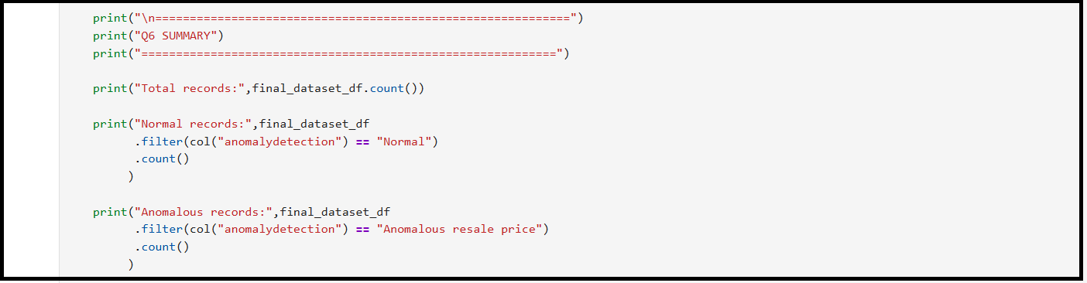
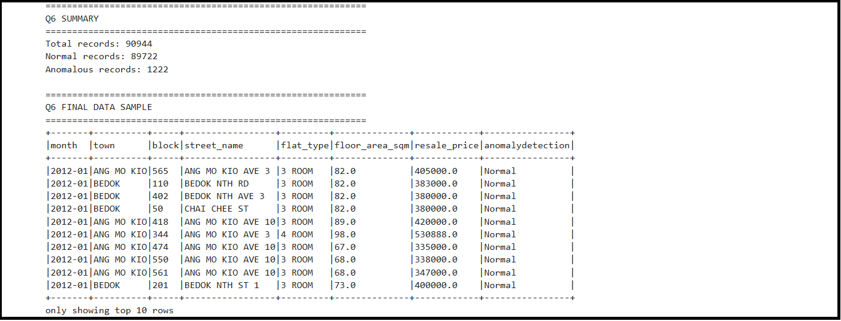

7. Additional Data Cleaning & Validation
This step introduces extra rules to ensure the dataset remains accurate, consistent, and reliable. It includes mechanisms to catch hidden errors, enforce realistic ranges, and flag anomalies for review. Even if the dataset appears clean, these rules demonstrate resilience and prepare the pipeline for messy or unexpected data in future ingestions.
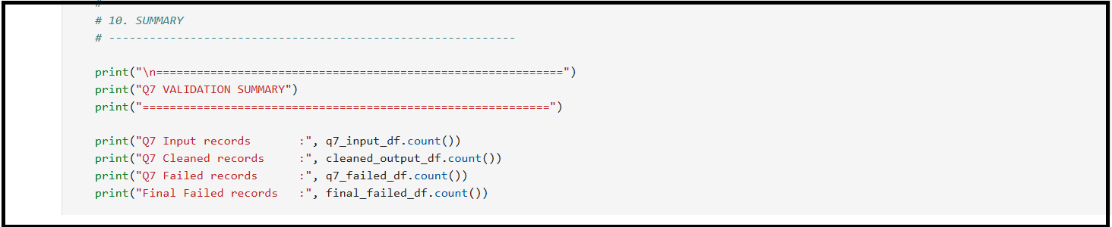
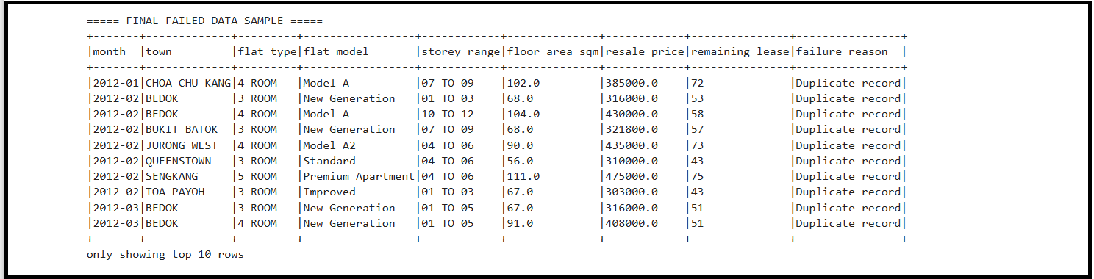

8. Transformation – Resale Identifier & Hashing
Generate a unique “Resale Identifier” string based on block, average price digits, month, and town initial. Hash the identifier using an irreversible algorithm (e.g., SHA-256) to preserve uniqueness and security.
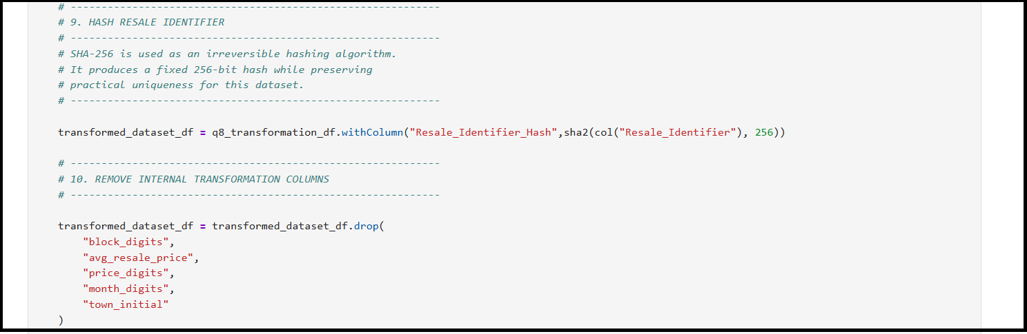

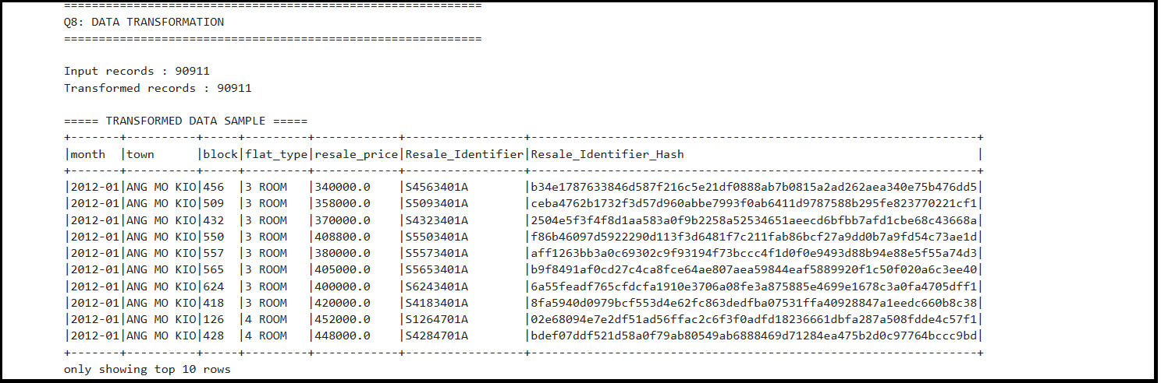

8. Output Files
Produce structured outputs:
Folder Name | Dataset / Content | Purpose
HDB_Raw_Dataset | Original HDB Source CSV Files | Stores the 3 original HDB datasets exactly as received, without modification.
HDB_Master_Raw | Master Raw Dataset | Consolidates the raw HDB source files into a single dataset while preserving the original source information.
HDB_Dataset_Cleaned | Validated & Deduplicated Dataset | Contains records that passed the mandatory data validation and deduplication rules. This is the final validated dataset.
HDB_Dataset_Failed | Failed / Rejected Records | Contains records that failed validation or were rejected during deduplication, including a failed_rule where applicable.
HDB_Additional_Data_Cleaning | Additional Data Cleaning Output | Contains data after applying additional standardisation, formatting, and data-cleaning rules beyond the initial validation.
HDB_Transformed_Hashed | Transformed & Hashed Dataset | Contains the cleaned data after applying the Resale Identifier transformation and hashing the required identifier.
HDB_ResalePrice_Anomaly_Detection | Resale Price Anomaly Detection Results | Contains resale records classified as Normal or Anomalous, together with relevant anomaly metrics or detection reasons.
HDB_Lease_Recalculation | Lease Recalculated Dataset | Contains the processed HDB resale data with the required lease-related values recalculated according to the defined business rules.

9. Folder Structure
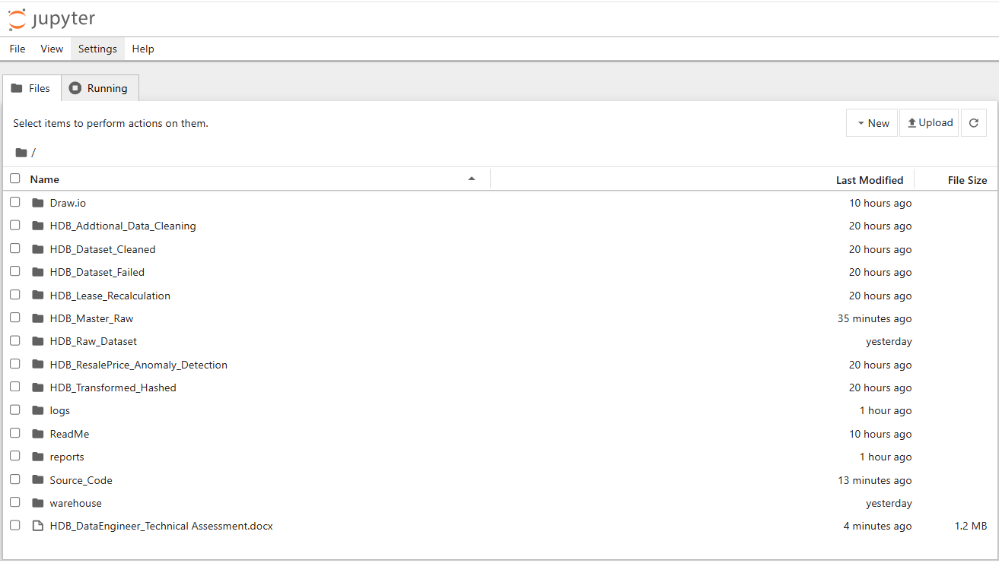

Architecture Overview
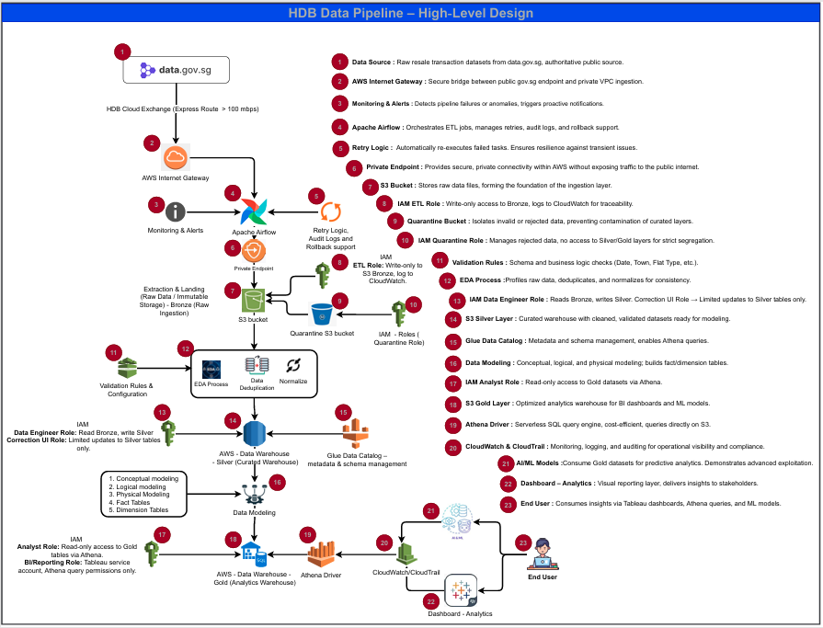

The architecture design is provided in SVG format for clarity, as some icons were missing when exporting the diagram from Draw.io to JPEG or PNG. Therefore, I have included the SVG file along with the PDF and Draw.io files. Please refer to the image for a detailed view.

Ingestion Layer
- gov.sg Data Source → Authoritative source of housing/demographic datasets, accessed securely via HTTPS.
- AWS Internet Gateway → Connects the VPC to the public internet, required for secure ingestion of gov.sg datasets.
- Apache Airflow → Orchestrates ingestion jobs, provides monitoring, alerting, and retry logic for reliability, auditability, and resilience.
- Amazon S3 Bronze → Raw landing zone, immutable storage for ingested files, ensuring durability and scalability.
Data Quality & Processing
- Quarantine Bucket → Isolates rejected or invalid data, preventing contamination of curated layers.
- EDA Process → Profiles raw data to detect anomalies early.
- Validation Rules → Enforces schema and business rules before data moves forward.
- AWS Glue → Performs deduplication, normalization, and validation in a serverless ETL environment tightly integrated with S3.
- Glue Data Catalog → Central metadata repository, enables Athena queries by defining schemas.
Curation & Warehouse
- Amazon S3 Silver → Curated warehouse layer, stores cleaned and validated datasets ready for modeling.
- Data Modeling → Conceptual, logical, and physical modeling, plus fact/dimension tables for structured analytics.
- Amazon S3 Gold → Analytics warehouse layer, optimized for query performance and BI consumption.
Analytics & BI
- Amazon Athena → Serverless SQL query engine, cost-efficient, queries directly on S3.
- AWS PrivateLink → Provides private endpoints, ensuring queries run securely without public internet exposure.
- Tableau → BI dashboards for visualization, enterprise-grade reporting.
- AI/ML Models → Consume Gold datasets for predictive analytics, demonstrating advanced use cases.
Governance & Monitoring
- IAM Role Segregation → ETL, Analyst, BI, and Correction UI roles enforce least-privilege access and compliance.
- CloudWatch & CloudTrail → Monitoring, logging, and auditing for operational visibility and regulatory compliance.
- Monitoring & Alerts → Detects pipeline failures or anomalies and triggers notifications for proactive response.
- Retry Logic → Automatically re-executes failed tasks, ensuring resilience against transient issues.

Conclusion
Future enhancements include streaming telemetry ingestion and real-time dashboards, delivering near real-time insights to strengthen decision-making.

